Overview - Transfer Learning

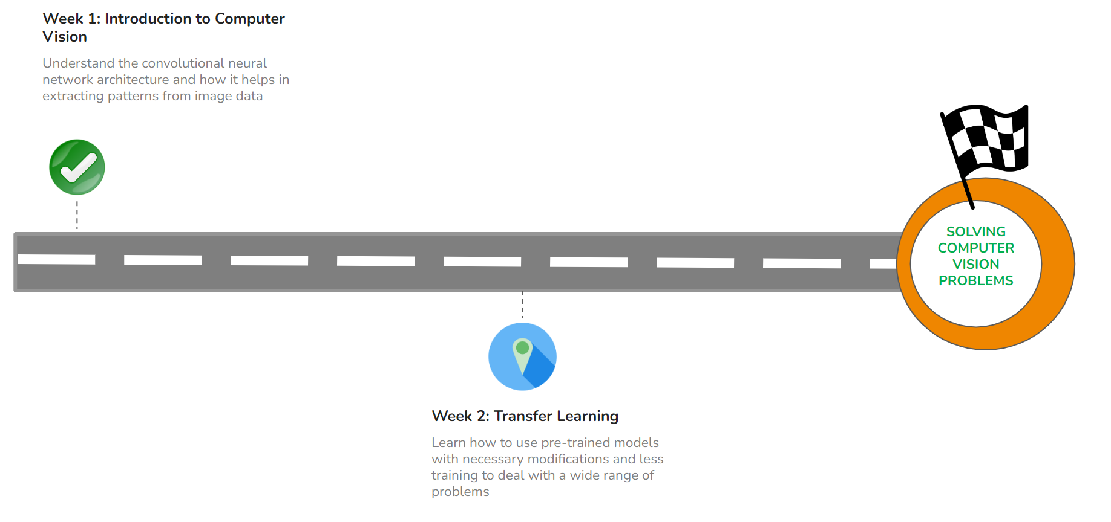

#### **QUICK RECAP**

In the previous week, we learned about the different layers of CNN architecture. Let us quickly recap what we have covered so far.

* How convolutional neural networks are different from artificial neural networks
* Convolutional neural networks architecture
  + Convolution Layer
  + Pooling Layer
  + Fully-connected Layer

#### **COURSE OVERVIEW**

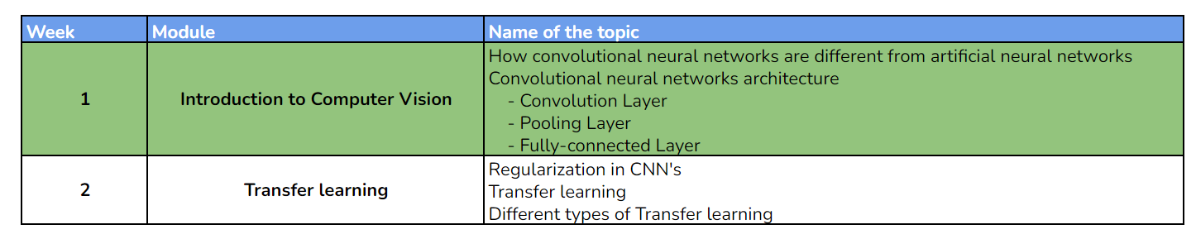

#### **WEEK 2 OVERVIEW**

This week, we will be learning about how to use pre trained models to deal with wide range of problems. The following topics will be covered in this module:

* Regularization in CNNs
* Transfer learning
* Different types of transfer learning

#### **LEARNING INSTRUMENTS**

| **Week** | **Module** | **No. of videos** | **Total duration** | **No. of Test Your Understanding Quizzes** | **No. of Weekly Graded Quizzes** |
| --- | --- | --- | --- | --- | --- |
| 2 | Introduction to Transfer learning | 5 | ~1.5 hours | 5 | 1 |

#### **Note: It is recommended to spend at least 1 hour/day along with practicing datasets and quizzes.**

**Power Ahead!**